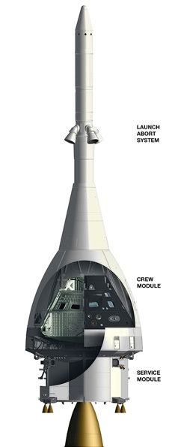
Request for Proposals
Background
NASA is currently designing and testing the Orion Multi-Purpose Crew Vehicle (MPCV). Orion will serve as NASA’s new exploration vehicle to carry astronauts to space and safely return them to earth. Orion will have a Launch Abort System tower positioned on top of the Crew Module. The Launch Abort System is an essential component to the safety of the crew members for Orion. In the event of an emergency on the launch pad, during launch, or during the climb to orbit; the Launch Abort System activates within milliseconds to propel the crew module to safety.

Request for Proposals
NASA is looking for an engineering firm to build a launch abort system to be used on the Orion Multi-Purpose Crew Vehicle in the event of a pad abort. Interested firms will need to present data collected from their simulations and launch in written and verbal form on (insert date). NASA approved launches will be scheduled for (insert date) where NASA representatives will be present to evaluate the launch process and data collection techniques.

Requirements
Location: A successful Launch Abort System must have a water landing. A crew module failing to land in water will cause lasting injury to the astronauts due to impact force. To guarantee a water landing after a pad abort the crew module must travel minimum of (insert min distance) feet, but not more than (insert max distance) feet. Any landing outside of this range would be considered an unacceptable error.
Time: Adequate time is also necessary for the launch abort system to deploy the parachutes. The crew module must remain airborne for at least (min seconds) seconds. However, if the crew module remains airborne for too long the guidance control system will exhaust its fuel source resulting in an unguided situation for the crew module. For this reason the crew module must not remain airborne for more than (max seconds) seconds.

These restrictions are listed again for your convenience.

Minimum Distance:
Maximum Distance:
Minimum Airtime:
Maximum Airtime:

Thank you for your interest in NASA. Important dates to remember:

Launch Day:
Presentation Day:

